|  |  |
| --- | --- |
|  | **Scientific Fact Sheet**  Swiss Tropical and Public Health Institute Swiss TPH for the Swiss Malaria Group  16 April 2018 |

Malaria and the UN Sustainable Development Goals (SDGs) 2030

# Introduction

Malaria continues to be a threat to the socio-economic development of 91 countries worldwide. Remarkable progress has been achieved in the fight against malaria in the past 15 years, with **more than 6 million lives saved** and a 45 percent decrease in the number of cases between 2000 and 2015.1

However, the 2017 World Malaria report raises concerns that the gains made in the fight against malaria are levelling off.2 In 2016, 216 million cases of malaria were reported, an increase of 5 million cases from the previous year. Most of these (90%) happened in the African Region. There is an urgent need to increase malaria efforts and not lose momentum.2

Three key milestones were achieved in 2016 to accelerate progress towards malaria control and elimination with the global launch of the WHO Global Technical Strategy for Malaria 2016–2030 (GTS); the Roll Back Malaria advocacy plan; Action and Investment to defeat Malaria 2016-2030 (AIM) and the Sustainable Development Goals (SDGs) with Target 3.3 focused on ending AIDS, tuberculosis, malaria and neglected tropical diseases epidemics. All these milestones share the same objective towards **malaria mortality and case reduction of >90% by 2030**.3

Sustainable Development Goals

On 25 September 2015, the UN General Assembly adopted the agenda of the Sustainable Development Goals to be accomplished by 2030. In a global and consultative effort, 17 SDGs and 169 targets were defined with the ambitious objective of leaving no one behind. The SDGs have an overarching focus on reducing global inequities and ending poverty. They emphasize six essential elements: people, prosperity, dignity, justice, the planet and partnership.4

The SDGs were established to build on the Millennium Development Goals (MDGs) and address any unfinished business. 5

**The achievement of a malaria-free world is arguably linked to most of the SDGs.** Malaria reduction and elimination will contribute to, benefit from and be a measure of progress towards the SDGs.4

In this fact sheet, we will address how the malaria fight will contribute to the progress of six of the most relevant SDGs and how this will make a contribution to global equity.

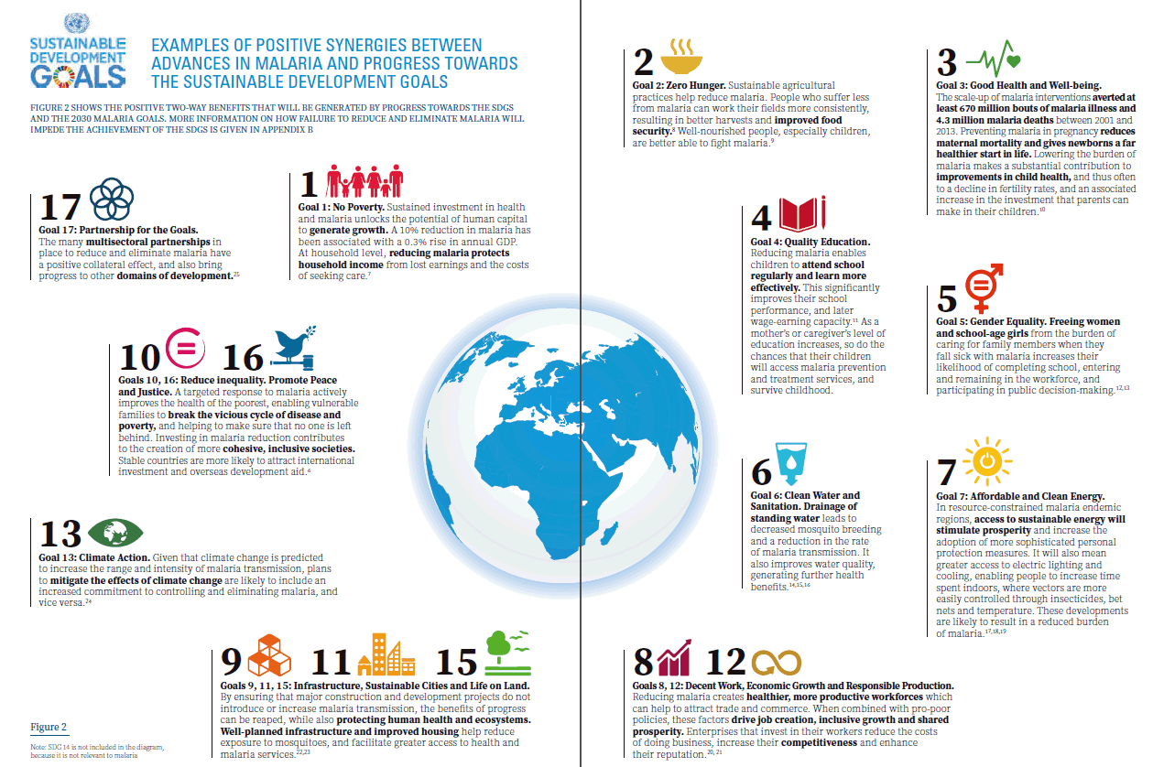

# GOAL 1: No Poverty

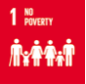officeArt object

The burden of malaria is highest among the most disadvantaged populations, particularly children and pregnant women. Global poverty and inequity are both a major cause and consequence of malaria. Investments in malaria will help **break the disease-poverty cycle** and allow people to build sustainable benefits.4

Malaria interventions are one of the most cost-effective interventions in public health.4

The cost of malaria for households has shown to be enormous. The direct health expenditure costs of malaria are at least 2.67$ per episode, in a population that generally struggles to live with 2.5$ per day. Malaria burden also has high indirect costs as each episode leads to an average of 3.4 days of lost productivity. Caregivers sacrifice a further 2-4 days each time a child or family member contracts malaria, which in turn increases the economic burden. 4

Several studies have explored the economic benefits of malaria elimination in different settings. In the USA and Latin American countries, exposure to malaria elimination programmes was associated with less work disability7 and higher incomes8 when reaching adulthood.

Southern European countries are also examples of success stories in malaria eradication. Malaria burden used to be high, as shown in Figure 1. Studies suggest there was substantial growth in these countries compared to neighbouring countries after malaria eradication.9

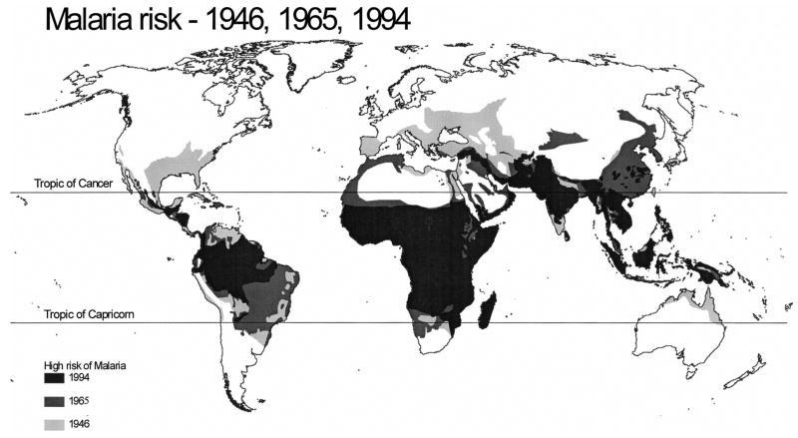

**Figure 1: Malaria risk, 1946, 1965, 1994.9**

# GOAL 2: Zero Hunger

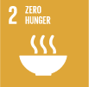

In the face of population pressures, there is a growing need for sustainable agriculture to improve farming productivity and food security. 4

**Agriculture and malaria have a two-way effect, as some agricultural practices or malpractices increase the risk of malaria transmission and malaria burden reduces agricultural productivity.**10 In high-burden areas, people who suffer malaria can work their fields less consistently, resulting in worse harvests and higher food insecurity. 11, 12

Good agricultural practices may reduce mosquito presence, and improved farming productivity may indirectly contribute to increased incomes, improved nutrition and social development and thus reduce the vulnerability of the people living in rural areas.13officeArt object

Furthermore, studies have shown that the combination of malaria and malnutrition (including deficiencies of iron, zinc or vitamin A) is particularly deadly.11

Fighting malaria will therefore directly contribute to targets 2.1) end hunger and ensure access to nutritious food, especially by the poor, 2.2) end all forms of malnutrition and 2.3) double the agricultural productivity and incomes of small-scale food producers.

# GOAL 3: Good Health and Well-being

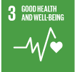

Health is seen as a **key factor for sustainable development.** SDG 3 aims to ensure healthy lives and promote well-being for all of all ages by 2030.1

Between the years 2000 and 2015, the fight against malaria averted over 6.2 million deaths, mainly of children under five in sub-Saharan Africa. 1

Decreasing the malaria burden will directly contribute to achieving target 3.3, which specifically aims to end the epidemics of AIDS, tuberculosis, malaria and neglected tropical diseases by 2030.

Furthermore, malaria reduction will also help to achieve 3.1)By 2030, reduce the global maternal mortality ratio to less than 70 per 100,000 live births, 3.2) By 2030, end preventable deaths of newborns and children under 5 years of age, with all countries aiming to reduce neonatal mortality to at least as low as 12 per 1,000 live births and under-5 mortality to at least as low as 25 per 1,000 live births and ultimately universal access to malaria prevention and treatment will contribute to target 3.8) Achieve universal health coverage, including financial risk protection, access to quality essential health-care services and access to safe, effective, quality and affordable essential medicines and vaccines for all.officeArt object

The before mentioned targets may seem ambitious, but the world has already taken huge steps towards achieving them. Under the umbrella of the MDGs, the global under-five mortality rate has declined by more than half, dropping from 90 to 43 deaths per 1,000 live births and the maternal mortality ratio has declined by 45 percent worldwide between 1990 and 2015. 14

Malaria is a significant contributor to maternal and neonatal mortality. Experiencing malaria during pregnancy causes anaemia, which increases the risk of maternal death during delivery, as well as neonatal death. These outcomes are entirely preventable and increasing access to malaria prevention in pregnant women will lead to direct improvements in maternal, newborn and infant health.15

Lowering the burden of malaria makes a substantial contribution to improvements in child health. At the same time, reductions in child mortality have been associated with declines in fertility rates.4,16 "Simply put, when parents don't know whether their children will survive, they respond by having large families." 17As child deaths decline, parents often choose to have smaller families and focus on supporting each child so they realize their full potential.

The reduction of malaria burden will also benefit other diseases, as well as help improve entire health systems. In high-transmission settings, malaria can account for up to 50% of hospital visits. For this reason, reducing this burden enables the relocation of resources to the treatment of other diseases.4

# GOAL 4: Quality Education

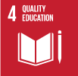

SDG4 aims to ensure inclusive and equitable quality education and promote lifelong learning opportunities for all. Inclusive quality education is a powerful and proven vehicle for sustainable development. 18

As seen in the previous examples, malaria has also a two-way effect on education. The probability of dying from malaria is higher with lower income and education.19 Conversely, malaria can prevent children from taking better advantage of their schooling. In a study evaluating 14 countries with malaria control campaigns, it was shown that control campaigns positively affected the amount of schooling years pupils completed as well as the grades they achieved during the current school year of primary school children.20 In 2013, Malaria No More UK highlighted how up to 50% of preventable school absenteeism in Africa is caused by malaria.21

A study in Mali showed that malaria is not only the main cause of school absenteeism, but also directly correlated with educational achievement and cognitive performance. This study concluded that fighting malaria could have a large payoff in terms of improving the primary education of many children in developing countries.22officeArt object

An examination in Paraguay and Sri Lanka showed that a reduction of 10% in malaria incidence increased how long girls stayed in school by 0.1 years. Moreover, this reduction improved the chances of being literate among girls by 1-2%23 This increase is shown in Figure 2 and demonstrates when malaria was eradicated in Sri Lanka.

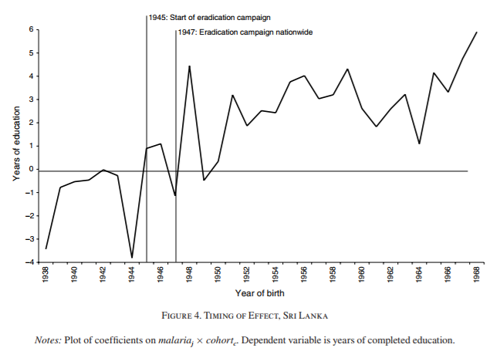

**Figure 2: Timing of effect on Education in girls, Sri Lanka23**

The education sector has an obligation to systematically include health promotion and malaria awareness in school curricula and other educational opportunities.4

# GOAL 5: Gender Equality

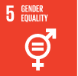

Women and girls worldwide are deprived of their basic rights and opportunities because of gender inequalities. SDG 5 aims to achieve gender equality and empower all women and girls by 2030.24 In the last 15 years, the progress has been remarkable, with many more girls attending schools and a higher share of women in parliamentary positions. However, the work remains unfinished. 14officeArt object

Malaria control will highly contribute to this goal as it will reduce women’s absence from work and school by reducing the time they are sick, as has been seen with SDG2 and SDG4. In addition to this, women will also spend less time taking care of their household members due to malaria sickness. Women and girls are the main caregivers in households. It has been measured that caregivers invest at least 2 days of their time for each household malaria episode. 25In high-transmission settings, this accumulates and forms a significant loss of productive time.

Malaria undermines the essential labour output of women who are responsible for the production of 70-80% of food crop in sub-Saharan Africa. It interrupts the production cycle and causes resources to be diverted from farm inputs.

By making sure that women can attend school, other long-term effects will be achieved. Increased schooling in mothers is an important factor in ensuring children access malaria prevention and treatment services. 4

Pregnant women are at greater risk for severe malaria. Studies have shown that adolescent pregnant girls are particularly endangered, as they often face more difficulties in accessing healthcare facilities and might not seek timely care for malaria.26

It is critical that moving forwards, malaria interventions pay attention to gender differences.

# GOAL 10, 16: Reduced inequalities and peace and justice, strong institutions

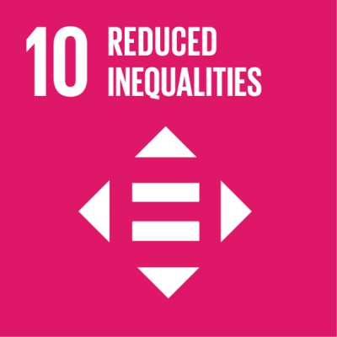 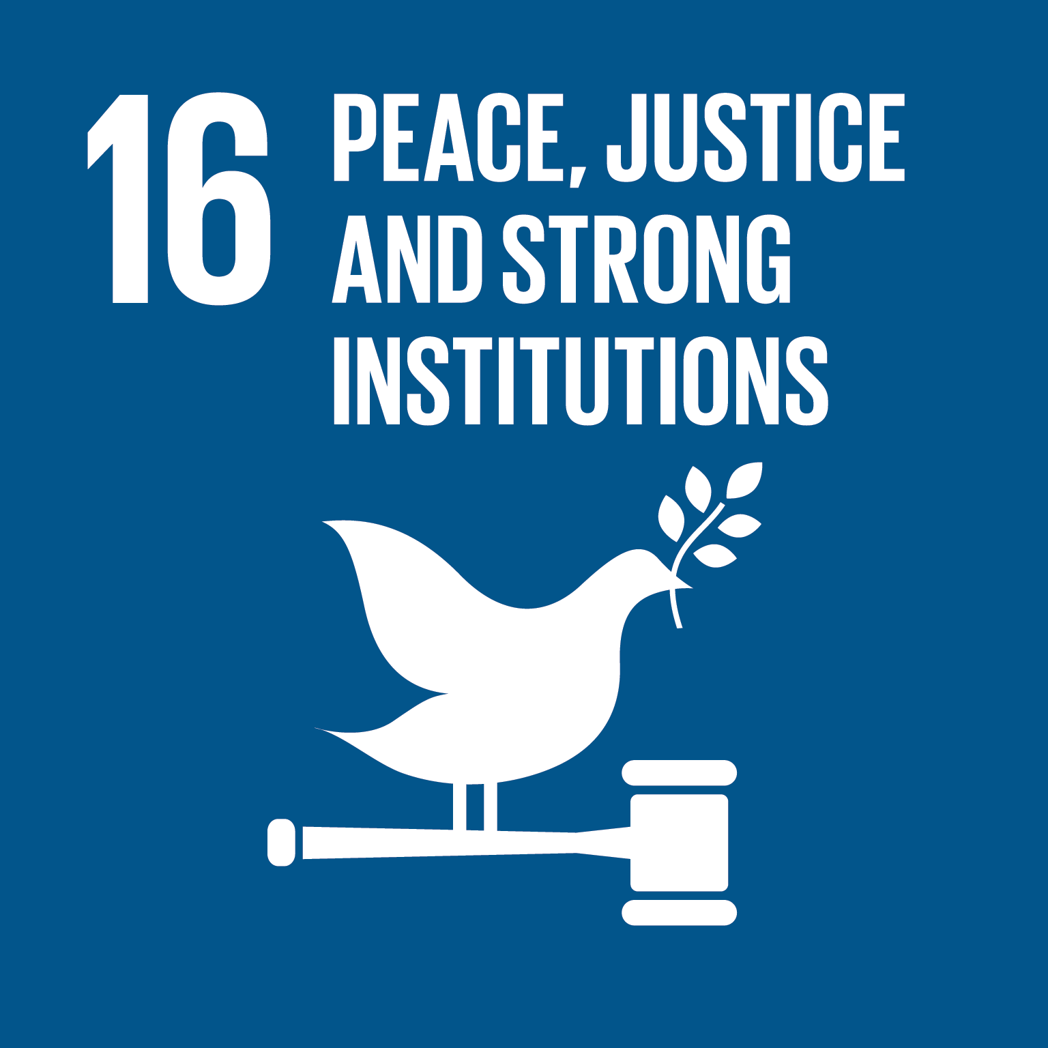

It is well documented that income inequality is on the rise. According to the United Nations Development programme, the richest 10 percent are earning up to 40 percent of total global income. The poorest 10 percent earn between 2 and 7 percent of total global income. In developing countries, inequality has increased by 11 percent, especially if we take into account the growth of population.

An expenditure impact study suggests that for **each US dollar invested in malaria control, there is an increase of 6.75$US in GDP per capita**.6 As Malaria is most entrenched in the poorest countries of the developing world, malaria engagement actively promotes reduced economic inequalities between countries.

A targeted response to malaria actively improves the health of the poorest, thereby enabling vulnerable families to break the vicious cycle of disease and poverty.4,6,7 Investing in malaria reduction contributes to the creation of more cohesive, inclusive societies. Stable countries are more likely to attract international investment and overseas development aid.

# GOAL 13: Climate action

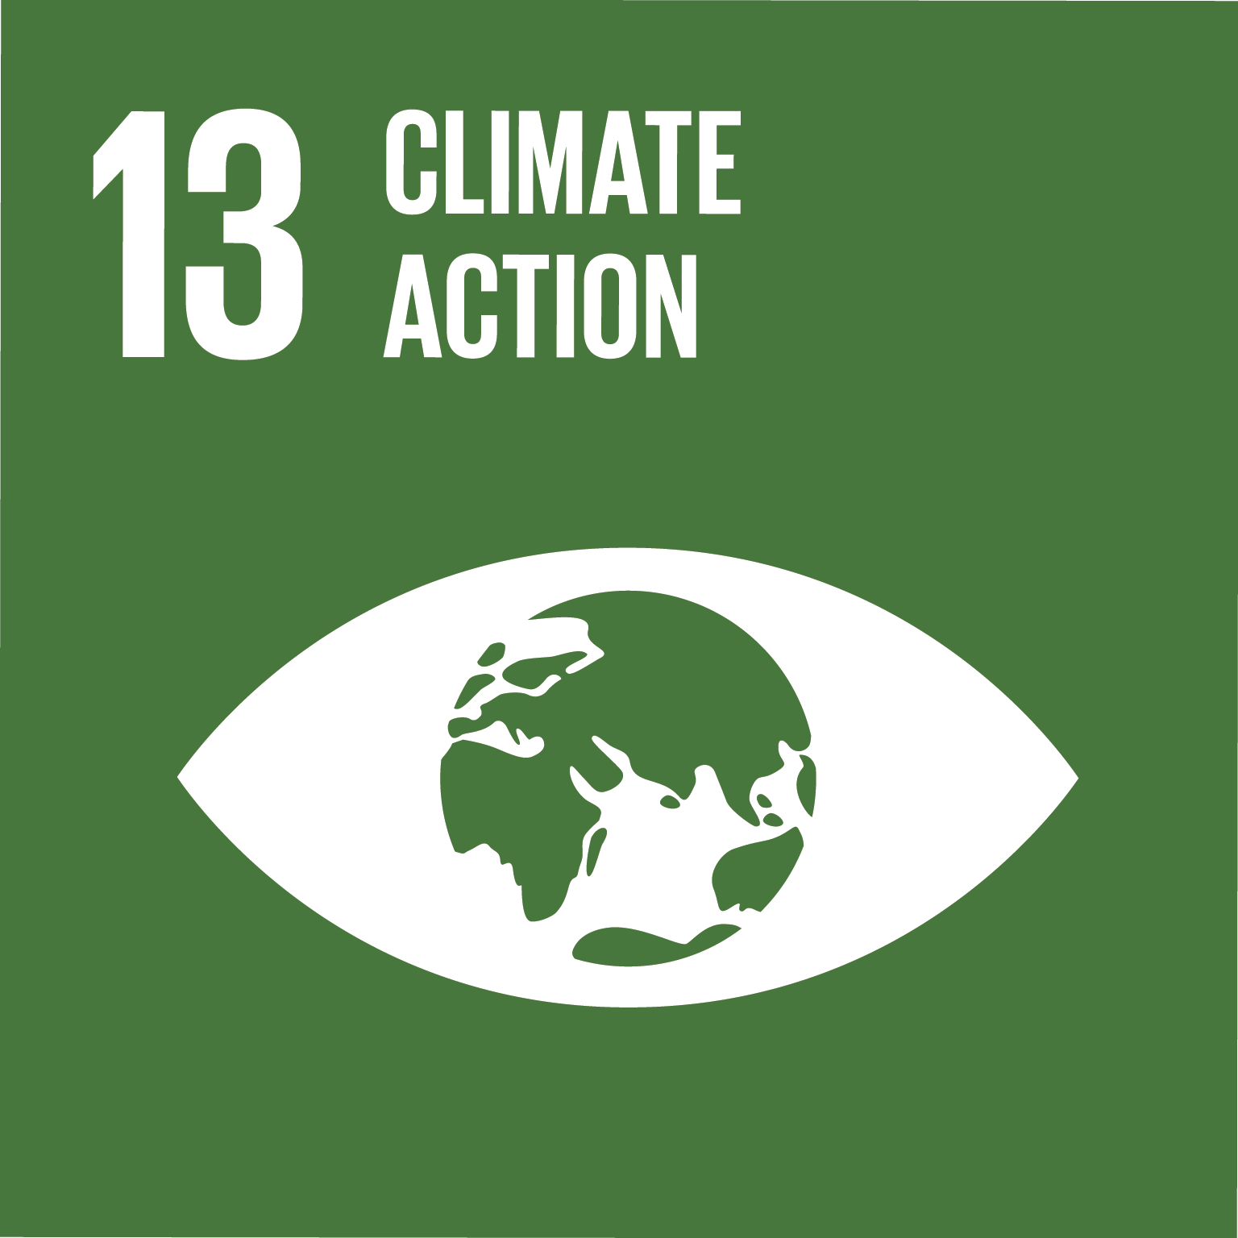

# As climate change is predicted to increase the range and intensity of malaria transmission, plans to mitigate the effects of climate change are likely to include an increased commitment to controlling and eliminating malaria and vice versa. Given the association between malaria transmission and climate, long-term malaria efforts will be highly sensitive to changes in the world’s climate. It is expected that – without mitigation – climate change will increase the malaria burden in several endemic regions of the world, particularly in densely populated tropical highlands. This will then potentially spread the disease to areas that have already eliminated it. Substantive investments in resilience and preparation need to be undertaken as soon as possible.

# GOAL 17: Partnerships for the goals

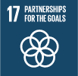officeArt object

The Sustainable Development Goals set an ambitious agenda for all countries worldwide. Achieving the targets by 2030 will require strong and revitalized partnerships which bring together governments, civil society, the private sector, the United Nations system and other actors. It will be necessary to mobilize all available resources. 27

Continued progress in the fight against malaria will depend on the ability to work together and build inclusive partnerships while addressing inequalities within and across boundaries and sectors everywhere.

The Multisectoral Action Framework for Malaria was released by Roll Back Malaria in 2013 and called for action at several levels and in multiple sectors, globally and across inter- and intra-national boundaries. It emphasized the complementarity, effectiveness and sustainability, and capitalized on the potential synergies to accelerate both socio-economic development and malaria control.28

Multisectoral collaboration has been and will remain key to addressing challenges raised by population mobility, the threat of drug and insecticide resistance, sustainable habitats, climate change and food security. The fight against malaria clearly represents the philosophy of the SDGs with their emphasis on partnership, solidarity and people-centred development.

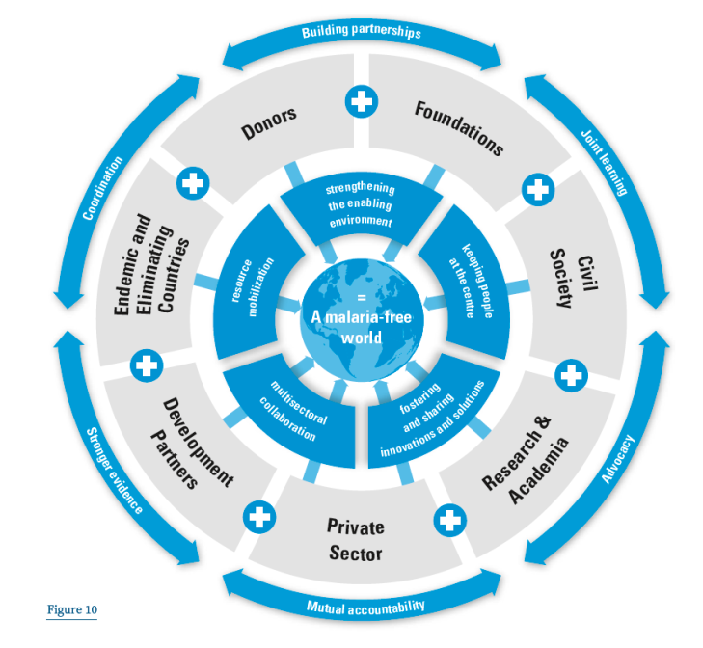

**Figure 3: All partners have important roles to play in the implementation of AIM4**

The benefits of these partnerships may surpass malaria and strengthening the relationships between donors and recipient organizations, and other health or development areas will benefit them as well.

Bibliography

1. Goal 3: Ensure healthy lives and promote well-being for all at all ages. *UN Sustainable Development Goals* Available at: http://www.un.org/sustainabledevelopment/health/page/2/.

2. World Health Organization (WHO). *World Malaria Report 2017*. (2017).

3. World Health Organization (WHO). *Global Technical Strategy for Malaria 2016–2030*. (2015).

4. World Health Organization (WHO). *Action and Investment for Malaria*. (2015).

5. Transforming our world: the 2030 Agenda for Sustainable Development .:. Sustainable Development Knowledge Platform. Available at: https://sustainabledevelopment.un.org/post2015/transformingourworld. (Accessed: 15th January 2018)

6. Jobin, W. Suppression of malaria transmission and increases in economic productivity in African countries from 2007 to 2011. *2014*

7. Hong, S. C. Malaria: An early indicator of later disease and work level. *J. Health Econ.***32,** 612–632 (2013).

8. Bleakley, H. Malaria Eradication in the Americas: A Retrospective Analysis of Childhood Exposure. *Am. Econ. J. Appl. Econ.***2,** (2010).

9. Gallup, J. L. & Sachs, J. D. The economic burden of malaria. *Am. J. Trop. Med. Hyg.***64,** 85–96 (2001).

10. Nkya, T. E. *et al.*Impact of agriculture on the selection of insecticide resistance in the malaria vector Anopheles gambiae: a multigenerational study in controlled conditions. *Parasit. Vectors 7.480* (2014).

11. International Food Policy research Institute. *The Linkages between Agriculture and Malaria*. (2009).

12. Keyamo Ochuko. Linkages between Malaria and Agriculture | GBCHealth. (2012). Available at: http://www.gbchealth.org/linkages-between-malaria-and-agriculture/. (Accessed: 23rd January 2018)

13. Roll Back Malaria (RBM) & SDG & Malaria Advocacy Working Group (MAWG). SDG and Malaria Briefing Paper.pdf. in (2016).

14. United Nations. *The Millennium Development Goals Report*. (2015).

15. Roll Back Malaria Partnership. *The contribution of malaria control to maternal and newborn health*. (2014).

16. Gakidou, E., Cowling, K., Lozano, R. & Murray, C. J. Increased educational attainment and its effect on child mortality in 175 countries between 1970 and 2009: a systematic analysis. *The Lancet 376***,** 959–974 (2010).

17. McCord, G. C., Conley, D. & Sachs, J. D. Malaria ecology, child mortality & fertility. *Econ. Hum. Biol.***24,** 1–17 (2017).

18. Goal 4: Quality education. *Sustainable Development Goals Fund* (2015). Available at: http://www.sdgfund.org/goal-4-quality-education. (Accessed: 23rd January 2018)

19. Tusting, L. S. *et al.*Socioeconomic development as an intervention against malaria: a systematic review and meta-analysis. *Lancet Lond. Engl.***382,** 963–972 (2013).

20. Kuecken, M., Thuilliez, J. & Valfort, M.-A. Does malaria control impact education? Evidence from Roll Back Malaria in Africa. (2015).

21. Roll Back Malaria. *RBM Education Fact Sheet*. (2015).

22. Thuilliez, J. *et al.* Malaria and primary education in Mali: a longitudinal study in the village of Donéguébougou. *Soc. Sci. Med. 1982***71,** 324–334 (2010).

23. Lucas, A. M. Malaria Eradication and Educational Attainment: Evidence from Paraguay and Sri Lanka. *Am. Econ. J. Appl. Econ.***2,** 46–71 (2010).

24. Goal 5 .:. Sustainable Development Knowledge Platform. Available at: https://sustainabledevelopment.un.org/sdg5. (Accessed: 23rd January 2018)

25. Asenso-Okyere, W. K. & Dzator, J. A. Household cost of seeking malaria care. A retrospective study of two districts in Ghana. *Soc. Sci. Med. 1982***45,** 659–667 (1997).

26. WHO, HIV/AIDS, TB and Malaria (HTM) & Roll Back Malaria (RBM). *Gender, Health and Malaria*. (2007).

27. Goal 17 .:. Sustainable Development Knowledge Platform. Available at: https://sustainabledevelopment.un.org/sdg17. (Accessed: 24th January 2018)

28. Roll Back Malaria, U. *Multisectoral-Action-Framework-for-Malaria.pdf*. (2013).

Appendix 1: Sustainable Development Goals Targets and Indicators

|  |  |
| --- | --- |
| **Goal 1. End poverty in all its forms everywhere** | |
| 1.1 By 2030, to eradicate extreme poverty for all people everywhere, currently measured as people living on less than $1.25 a day | 1.1.1 Proportion of population below the international poverty line, by sex, age, employment status and geographical location (urban/rural) |
| 1.2 By 2030, reduce at least by half the proportion of men, women and children of all ages living in poverty in all its dimensions according to national definitions | 1.2.1 Proportion of population living below the national poverty line, by sex and age |
| 1.2.2 Proportion of men, women and children of all ages living in poverty in all its dimensions according to national definitions |
| 1.4 By 2030, to ensure that all men and women, in particular the poor and the vulnerable, have equal rights to economic resources, as well as access to basic services, ownership and control over land and other forms of property, inheritance, natural resources, appropriate new technology and financial services, including microfinance | 1.4.1 Proportion of population living in households with access to basic services |
| 1.4.2 Proportion of total adult population with secure tenure rights to land, legally recognized documentation and who perceive their rights to land as secure, by sex and by type of tenure |
| 1.a Ensure significant mobilization of resources from a variety of sources: these include through enhanced development cooperation, in order to provide adequate and predictable means for developing and underdeveloped countries, as well as implement programmes and policies to end poverty in all its dimensions | 1.a.1 Proportion of domestically generated resources allocated by the government and given directly to poverty reduction programmes |
| 1.a.2 Proportion of total government spent on essential services (education, health and social protection) |
| 1.a.3 Sum of total grants and non-debt-creating inflows directly allocated to poverty reduction programmes as a proportion of GDP |
| 1.b Create sound policy frameworks at national, regional and international levels, based on pro-poor and gender-sensitive development strategies, to support accelerated investment in poverty eradication actions | 1.b.1 Proportion of government recurrent and capital spending to sectors that disproportionately benefit women, the poor and vulnerable groups |
| **Goal 2. End hunger, achieve food security and improved nutrition and promote sustainable agriculture** | |
| 2.1 By 2030, to end hunger and ensure access for all people, in particular the poor and people, including infants, who are in vulnerable situations, to safe, nutritious and sufficient food year round | 2.1.1 Prevalence of undernourishment |
| 2.1.2 Prevalence of moderate or severe food insecurity in the population, based on the Food Insecurity Experience Scale (FIES) |
| 2.2 By 2030, end all forms of malnutrition, including achieving, by 2025, the internationally agreed targets on stunting and wasting in children under 5 years of age, and address the nutritional needs of adolescent girls, pregnant and lactating women and older persons | 2.2.1 Prevalence of stunting (height for age <-2 standard deviation from the median of the World Health Organization (WHO) Child Growth Standards) among children under 5 years of age |
| 2.2.2 Prevalence of malnutrition (weight for height >+2 or <-2 standard deviation from the median of the WHO Child Growth Standards) among children under 5 years of age, by type (wasting and overweight) |
| 2.3 By 2030, to double the agricultural productivity and incomes of small-scale food producers, in particular women, indigenous peoples, family farmers, pastoralists and fishers, including through secure and equal access to land, other productive resources and inputs, knowledge, financial services, markets and opportunities for value addition and non-farm employment | 2.3.1 Volume of production per labour unit by classes of farming/pastoral/forestry enterprise size |
| 2.3.2 Average income of small-scale food producers, by sex and indigenous status |
| 2.a Increase investment, including through enhanced international cooperation, in rural infrastructure, agricultural research and extension services, technology development and plant and livestock gene banks in order to enhance agricultural productive capacity in developing countries, in particular least developed countries | 2.a.1 The agriculture orientation index for government expenditures |
| 2.a.2 Total official flows (official development assistance plus other official flows) to the agriculture sector |
| **Goal 3. Ensure healthy lives and promote well-being for all at all ages** | |
| 3.1 By 2030, to reduce the global maternal mortality ratio to less than 70 per 100,000 live births | 3.1.1 Maternal mortality ratio |
| 3.1.2 Proportion of births attended by skilled health personnel |
| 3.2 By 2030, to end preventable deaths of newborns and children under 5 years of age, with all countries aiming to reduce neonatal mortality to at least as low as 12 per 1,000 live births and under-5 mortality to at least as low as 25 per 1,000 live births | 3.2.1 Under-five mortality rate |
| 3.2.2 Neonatal mortality rate |
| 3.3 By 2030, to end the epidemics of AIDS, tuberculosis, malaria and neglected tropical diseases and combat hepatitis, water-borne diseases and other communicable diseases | 3.3.1 Number of new HIV infections per 1,000 uninfected population, by sex, age and key populations |
| 3.3.2 Tuberculosis incidence per 100,000 population |
| 3.3.3 Malaria incidence per 1,000 population |
| 3.3.4 Hepatitis B incidence per 100,000 population |
| 3.3.5 Number of people requiring interventions against neglected tropical diseases |
| 3.8 Achieve universal health coverage, including financial risk protection, access to quality essential health-care services and access to safe, effective, quality and affordable essential medicines and vaccines for all | 3.8.1 Coverage of essential health services (defined as the average coverage of essential services based on tracer interventions that include reproductive, maternal, newborn and child health, infectious diseases, non-communicable diseases and service capacity and access, among the general and the most disadvantaged population) |
| 3.8.2 Proportion of population with large household expenditures on health as a share of total household expenditure or income |
| 3.9 By 2030, to substantially reduce the number of deaths and illnesses from hazardous chemicals and air, water and soil pollution and contamination | 3.9.1 Mortality rate attributed to household and ambient air pollution |
| 3.9.2 Mortality rate attributed to unsafe water, unsafe sanitation and lack of hygiene (exposure to unsafe Water, Sanitation and Hygiene for All (WASH) services) |
| 3.9.3 Mortality rate attributed to unintentional poisoning |
| **Goal 4. Ensure inclusive and equitable quality education and promote lifelong learning opportunities for all** | |
| 4.1 By 2030, to ensure that all girls and boys complete free, equitable and quality primary and secondary education leading to relevant and effective learning outcomes | 4.1.1 Proportion of children and young people: (a) in grades 2/3; (b) at the end of primary; and (c) at the end of lower secondary achieving at least a minimum proficiency level in (i) reading and (ii) mathematics, by sex |
| 4.6 By 2030, to ensure that all youth and a substantial proportion of adults, both men and women, achieve literacy and numeracy | 4.6.1 Proportion of population in a given age group achieving at least a fixed level of proficiency in functional (a) literacy and (b) numeracy skills, by sex |
| 4.7 By 2030, ensure that all learners acquire the knowledge and skills needed to promote sustainable development. This includes through education for sustainable development and sustainable lifestyles, human rights, gender equality, promotion of a culture of peace and non-violence, global citizenship and appreciation of cultural diversity and of culture’s contribution to sustainable development | 4.7.1 Extent to which (i) global citizenship education and (ii) education for sustainable development, including gender equality and human rights, are mainstreamed at all levels in: (a) national education policies; (b) curricula; (c) teacher education; and (d) student assessment |
| **Goal 5. Achieve gender equality and empower all women and girls** | |
| 5.a Undertake reforms to give women equal rights to economic resources, as well as access to ownership and control over land and other forms of property, financial services, inheritance and natural resources, in accordance with national laws | 5.a.1 (a) Proportion of total agricultural population with ownership or secure rights over agricultural land, by sex; and (b) share of women among owners or rights-bearers of agricultural land, by type of tenure |
| 5.a.2 Proportion of countries where the legal framework (including customary law) guarantees women’s equal rights to land ownership and/or control |
| **Goal 17. Strengthen the means of implementation and revitalize the Global Partnership for Sustainable Development** | |
| **Finance** |  |
| 17.1 Strengthen domestic resource mobilization, including through international support to developing countries, to improve domestic capacity for tax and other revenue collection | 17.1.1 Total government revenue as a proportion of GDP, by source |
| 17.1.2 Proportion of domestic budget funded by domestic taxes |
| 17.2 Developed countries to implement fully their official development assistance commitments, including the commitment by many developed countries to achieve the target of 0.7 per cent of gross national income for official development assistance (ODA/GNI) to developing countries and 0.15 to 0.20 per cent of ODA/GNI to least developed countries; ODA providers are encouraged to consider setting a target to provide at least 0.20 percent of ODA/GNI to least developed countries | 17.2.1 Net official development assistance, total and to least developed countries, as a proportion of the Organization for Economic Cooperation and Development (OECD) Development Assistance Committee donors’ gross national income (GNI) |
| 17.3 Mobilize additional financial resources for developing countries from multiple sources | 17.3.1 Foreign direct investments (FDI), official development assistance and South-South Cooperation as a proportion of total domestic budget |
| 17.3.2 Volume of remittances (in United States dollars) as a proportion of total GDP |
| 17.5 Adopt and implement investment promotion regimes for least developed countries | 17.5.1 Number of countries that adopt and implement investment promotion regimes for least developed countries |
| **Technology** |  |
| 17.6 Enhance North-South, South-South and triangular regional and international cooperation on and access to science, technology and innovation and enhance knowledge-sharing on mutually agreed terms, including through improved coordination among existing mechanisms, in particular at the United Nations level, and through a global technology facilitation mechanism | 17.6.1 Number of science and/or technology cooperation agreements and programmes between countries, by type of cooperation |
| 17.6.2 Fixed Internet broadband subscriptions per 100 inhabitants, by speed |
| 17.7 Promote the development, transfer, dissemination and diffusion of environmentally sound technologies to developing countries on favourable terms, including on concessional and preferential terms, as mutually agreed | 17.7.1 Total amount of approved funding for developing countries to promote the development, transfer, dissemination and diffusion of environmentally sound technologies |
| **Capacity-building** |  |
| 17.9 Enhance international support for implementing effective and targeted capacity-building in developing countries to support national plans to implement all the Sustainable Development Goals, including through North-South, South-South and triangular cooperation | 17.9.1 Dollar value of financial and technical assistance (including through North-South, South-South and triangular cooperation) committed to developing countries |
| **Systemic issues** |  |
| *Policy and institutional coherence* |  |
| 17.13 Enhance global macroeconomic stability, including through policy coordination and policy coherence | 17.13.1 Macroeconomic Dashboard |
| 17.14 Enhance policy coherence for sustainable development | 17.14.1 Number of countries with mechanisms in place to enhance policy coherence of sustainable development |
| 17.15 Respect each country’s policy space and leadership to establish and implement policies for poverty eradication and sustainable development | 17.15.1 Extent of use of country-owned results frameworks and planning tools by providers of development cooperation |
| *Multi-stakeholder partnerships* |  |
| 17.16 Enhance the Global Partnership for Sustainable Development, complemented by multi-stakeholder partnerships that mobilize and share knowledge, expertise, technology and financial resources, to support the achievement of the Sustainable Development Goals in all countries, in particular developing countries | 17.16.1 Number of countries reporting progress in multi-stakeholder development effectiveness monitoring frameworks that support the achievement of the sustainable development goals |
| 17.17 Encourage and promote effective public, public-private and civil society partnerships, building on the experience and resourcing strategies of partnerships | 17.17.1 Amount of United States dollars committed to public-private and civil society partnerships |
| *Data, monitoring and accountability* |  |
| 17.18 By 2020, enhance capacity-building support to developing countries, including for least developed countries and small island developing States, to significantly increase the availability of high-quality, timely and reliable data disaggregated by income, gender, age, race, ethnicity, migratory status, disability, geographic location and other characteristics relevant in national contexts | 17.18.1 Proportion of sustainable development indicators produced at the national level with full disaggregation when relevant to the target, in accordance with the Fundamental Principles of Official Statistics |
| 17.18.2 Number of countries that have national statistical legislation and that comply with the Fundamental Principles of Official Statistics |
| 17.18.3 Number of countries with a national statistical plan that is fully funded and under implementation, by source of funding |